Game Progess Tracking

04/22/2024:

* Finish jumping and moving mechanic
* Add minor updates to enhance the jumping mechanic

04/22/2024 (23:47)

- Create sprite for game project

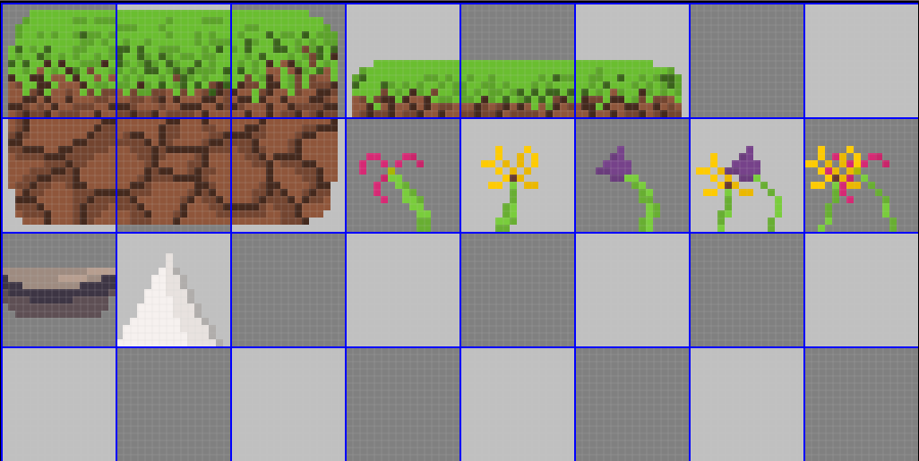

+ Grass block

+ Dirt block

+ Flowers

+ Rock

+ Spikes